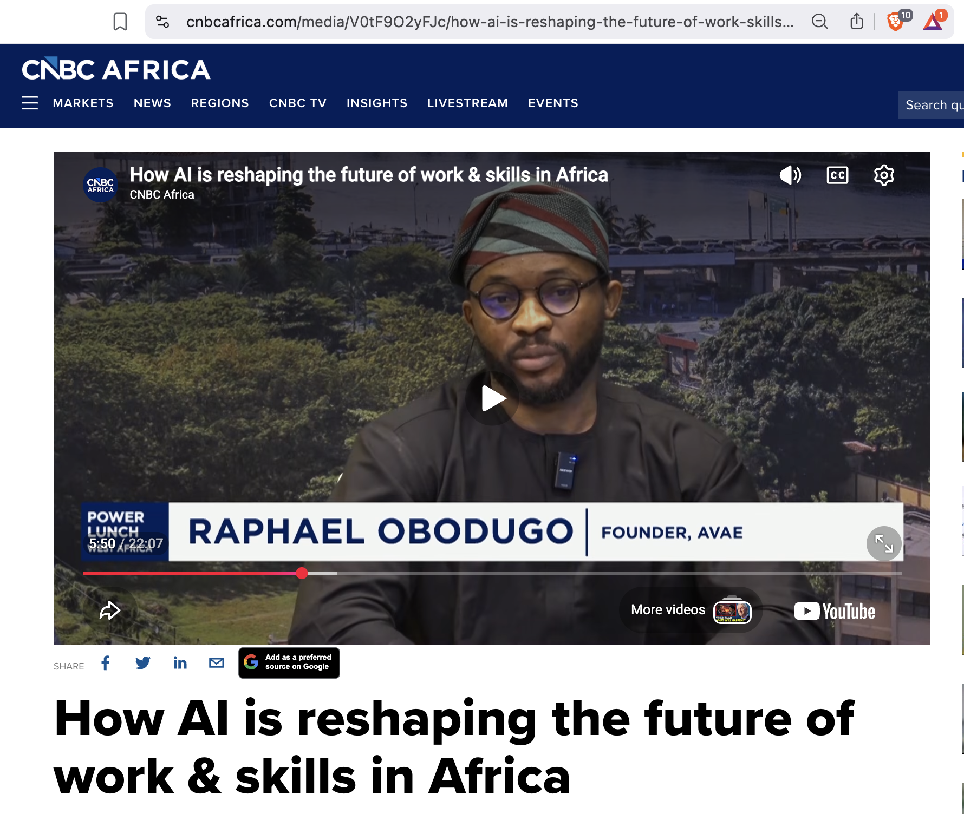
https://www.cnbcafrica.com/media/V0tF9O2yFJc/how-ai-is-reshaping-the-future-of-work-skills-in-africa

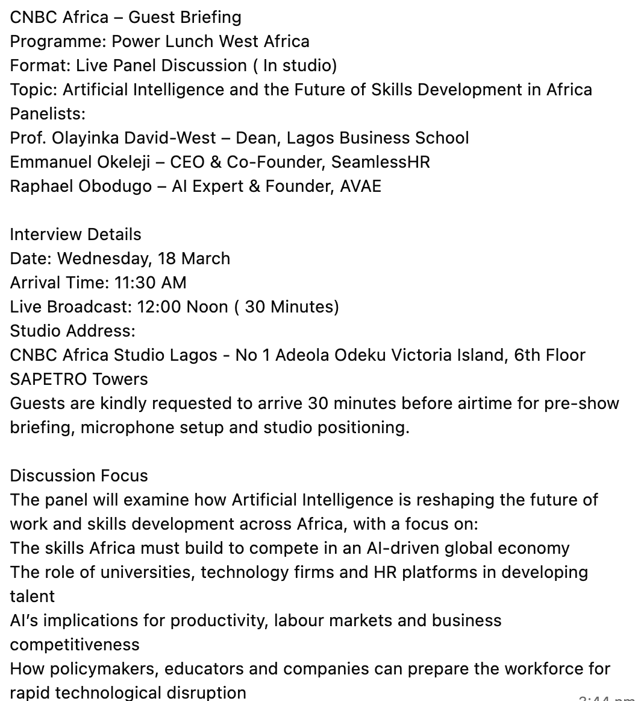

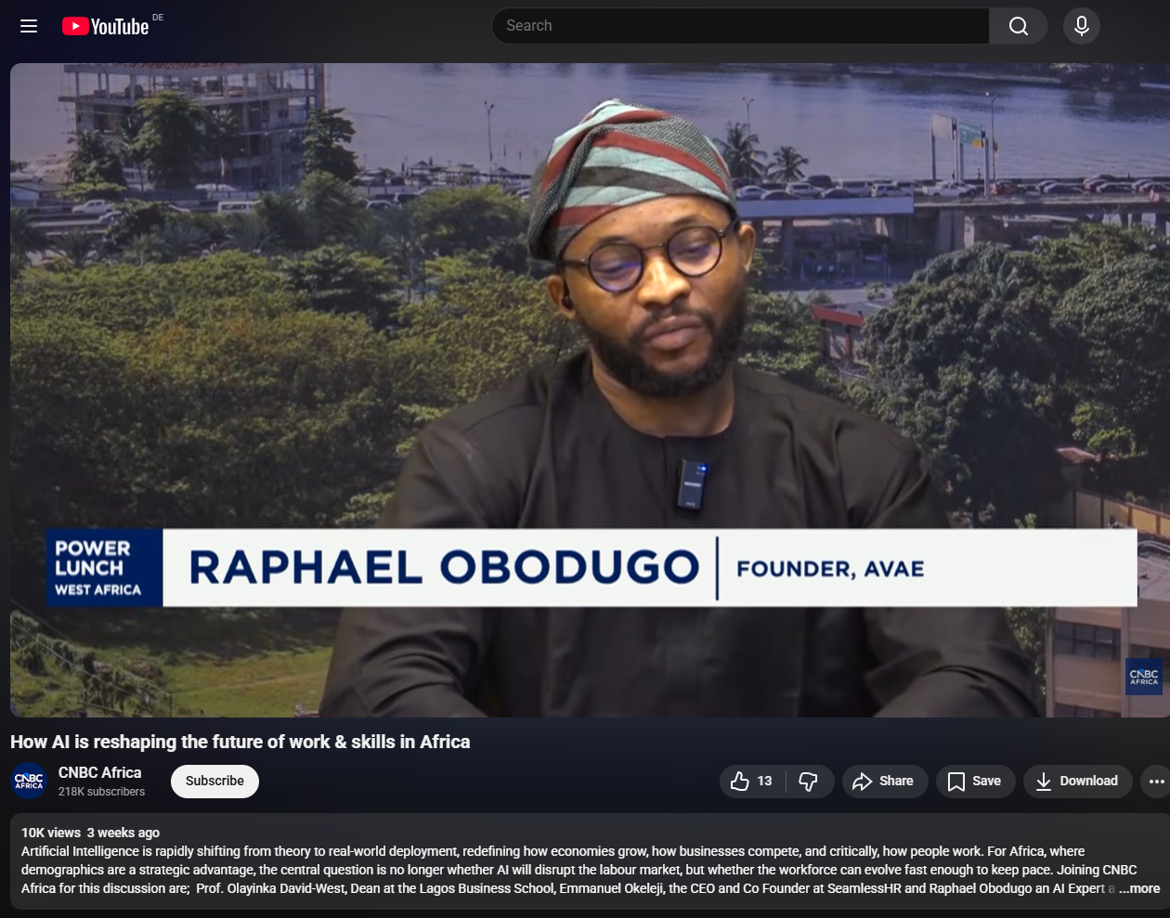
https://www.youtube.com/watch?v=V0tF9O2yFJc

